-JS can be executed by browsers(the only one)

-Activity 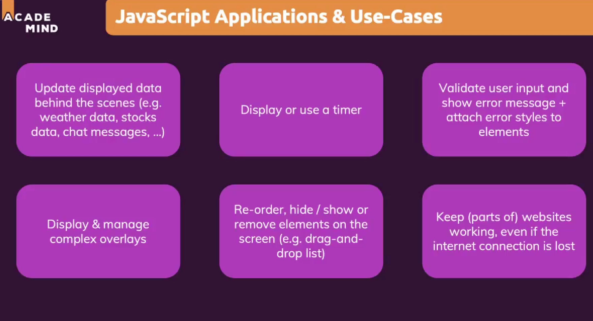

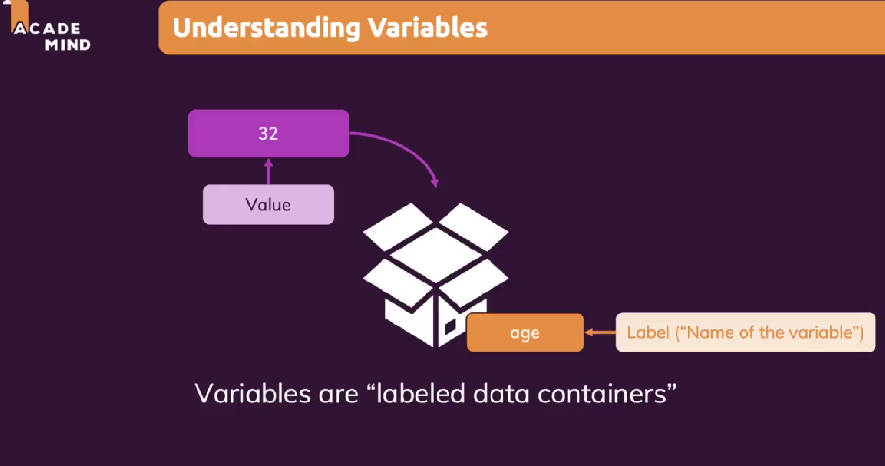

-In html file we can add <script> to write JS code

-It should be in the hesad

-We write strings between “” or ‘’ and it should not be switched onec chosen

-If I want to add “ or ‘ to the real text I need to add \ before it

-alert () is a kind of a pop up message which will show js code

-it can be used with numbers and strings

-let is a key word to create a variable

-The name of the variable needs to be one word and plain text with numbrs optionaly

-The name should start with a lower case and if there is a second word it should start with a uppercase(camelcase)

-Let is only used when creating a variable and we use the variable again with name = vaule

-We can overwrite variables and it is executed top to bottom left to right

-We should add ; at the end of the lines, especially if we have two functions in one line.It is not necessary and we should stay consisten with using or not using it like the quotes

-We can outsoure JS code in the .js file

-We link JS files with <script> src=”path or url”

-We create arrays with [] to use multiple values

-We can output a single value of the arrays with alert (name [index number of the value which we defined in the array])

-Functions are our own command that we write to execute whenever we want

-function name should not describe whats in them rather what the operation is about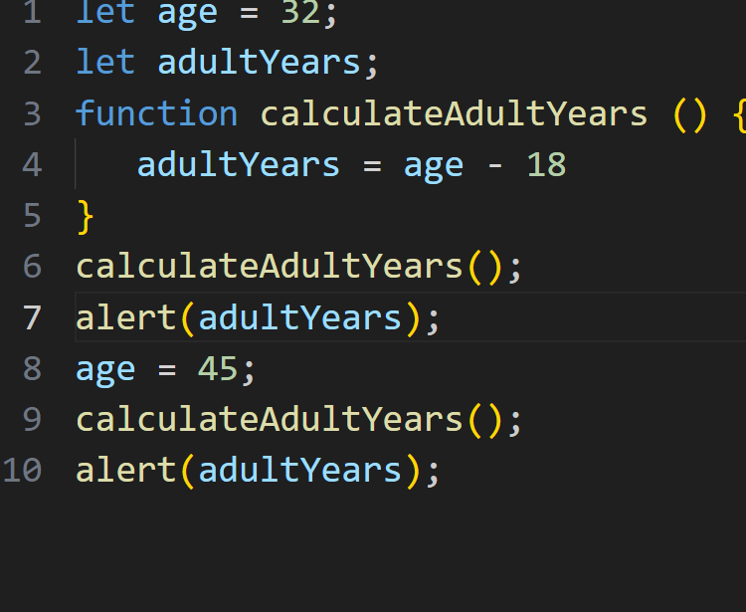

-If we create a variable in a function is only usable in that function

-return key word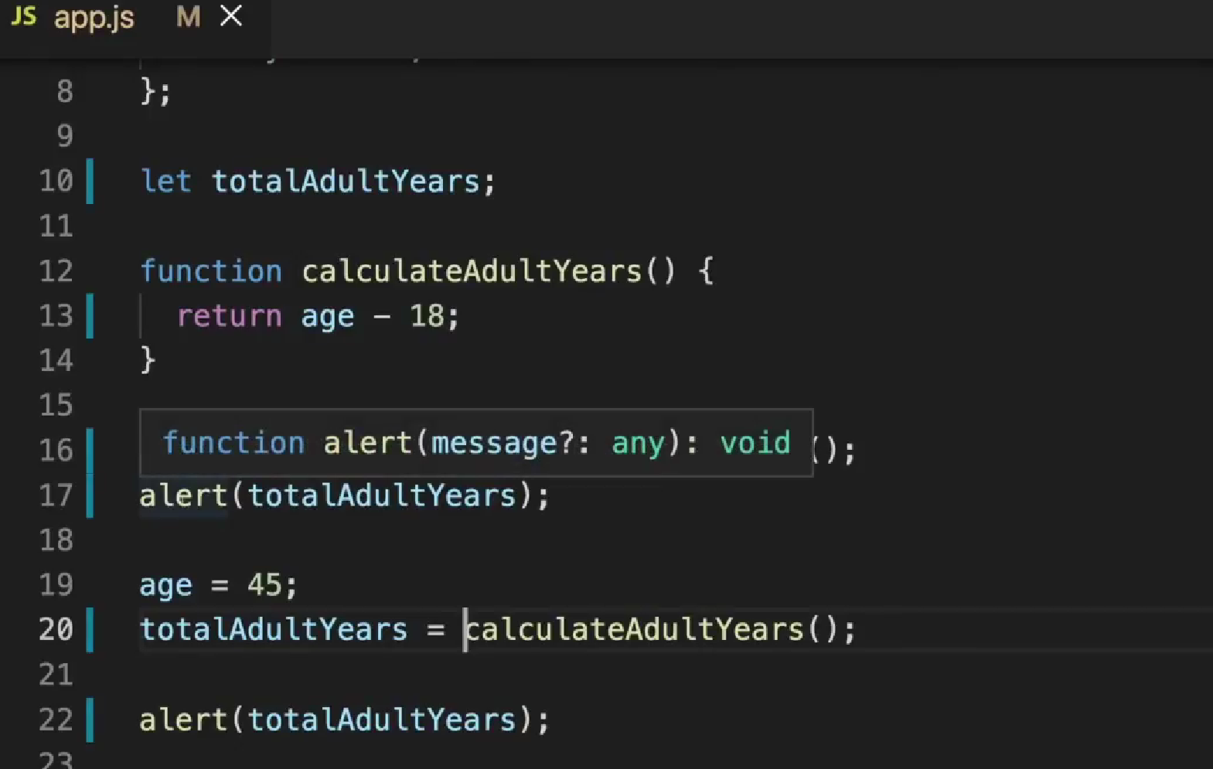

-Function parameters are the user inputs used in functions and it is placed in () when we write the function.And later we add the vaulue between () when we call a value we can add more parameters but need to use ,